Project 14: Web Colors

Objectives:

At the end of this project, you will be able to:
- Use Hex codes in CSS to create different colors on web pages.

Instructions:

- Create a new folder called "Web Colors".
- Create a new XHTML document and save it as "index.html" in the "Web Colors" folder.
- Set the title to be "Web Colors" and create a main <h1> heading that reads the same.
- Create a page that looks similar to the example provided below, with the following additional instructions:
- The background color of the page is #F5DEB3.
- The <h1> color is #2E8B57.
- For the first two boxes shown, set the background color to match the Hex code listed in the box. Place black text in the boxes as shown.
- For the third box, use a color picker tool to select your own background color, the only requirement being that it is a dark enough shade for white letters to be legible. Add the text showing your Hex code and set the text color to be white (using the Hex code instead of the color name).
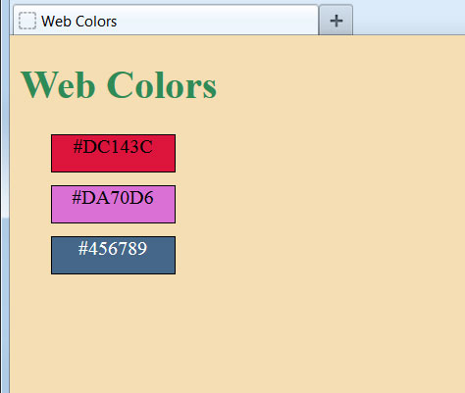

Rubric 14: Web Colors

Name: ____________________________

Component | Possible Points | Score
The <body> element has the background color property set to the Hex code provided. | 3
The <h1> text is set to the provided shade of green via Hex code. | 3
The first <div> box has the background color set to the Hex code shown and the text shows in black. | 3
The second <div> box has the background color set to the Hex code shown and the text shows in black. | 3
The text color for the final <div> is set to white, using Hex code. | 3
The background color for the final <div> is set via Hex code and the lettering is legible. | 5
Total Score | 20

